**16. Create a Cloning of a VM and Test it by loading the Previous Version/Cloned VM using vmware workstation.**

step 1 : select app services

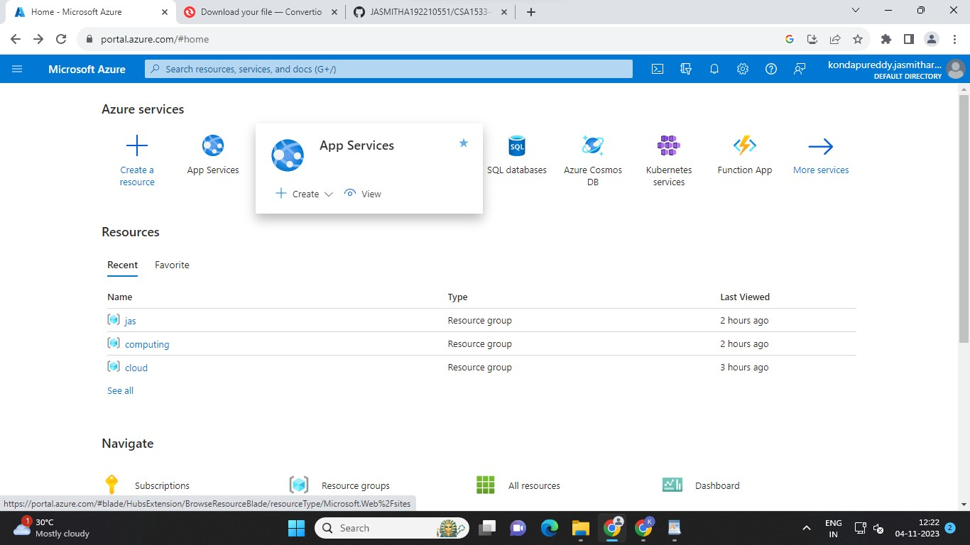

step 2 : create and then select web app

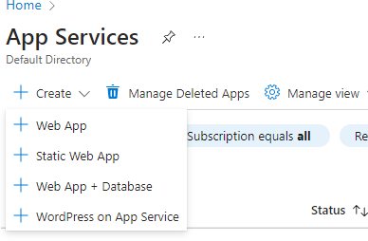

step 3 : type resource group and name it and then select static web app and click on pop up msg

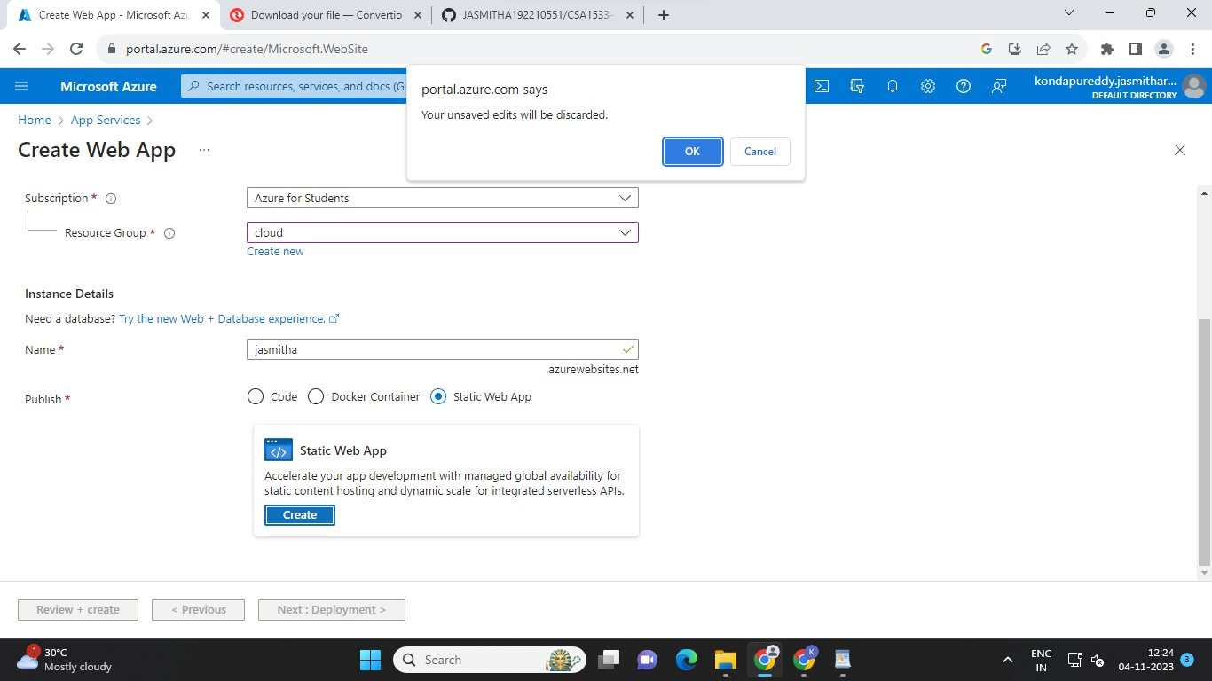

step 4 : after click next name it and click on other option

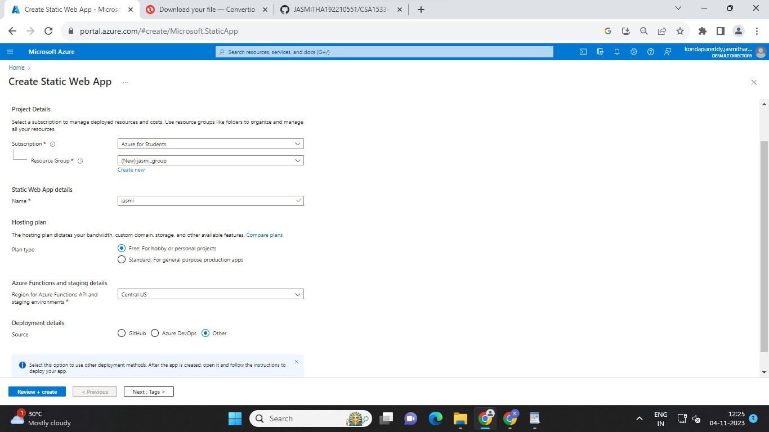

step 5 : add the tags and click on next and can see the complete data we entered

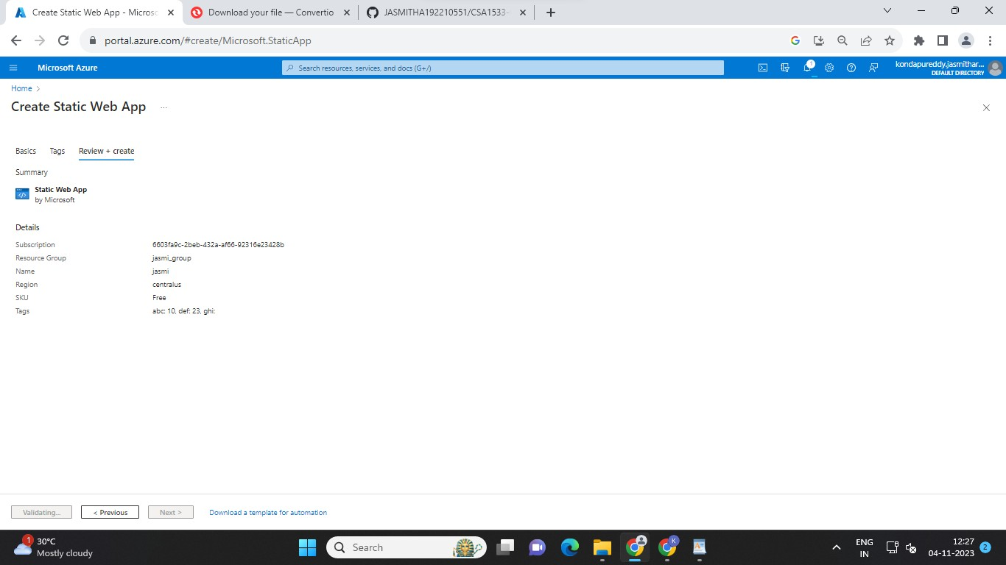

step 6 : create and then go resource

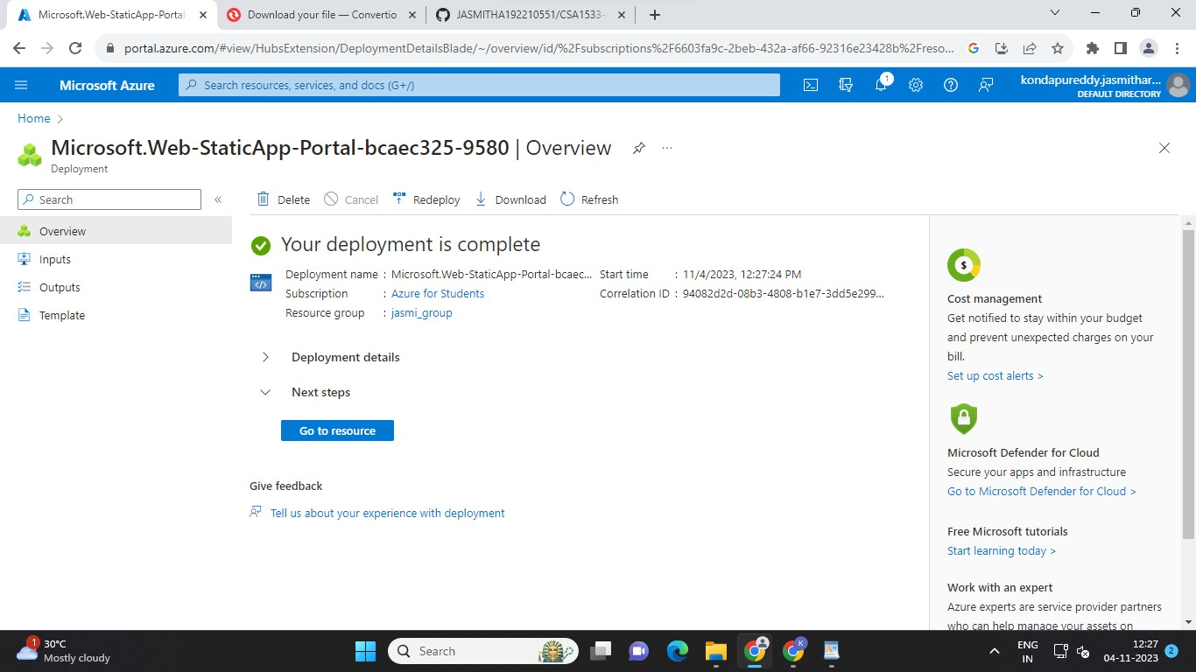

step 7 : output is done and can able to see the url link and copy and done

